ASSGINMENT 5.4
NAME : Uma Maheshwari
Batch:44
2303A52430
Task Description 1:
• Prompt GitHub Copilot to generate a Python script that collects
user data (e.g., name, age, email). Then, ask Copilot to add
comments on how to anonymize or protect this data.
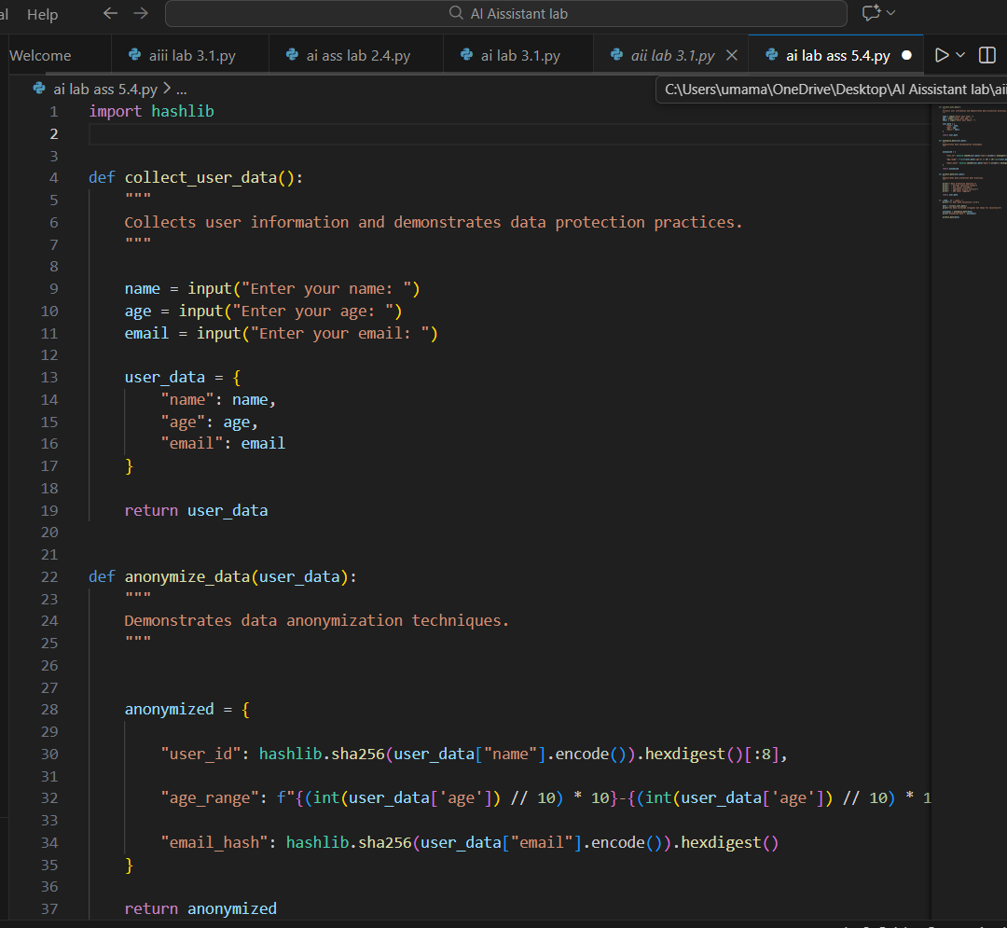
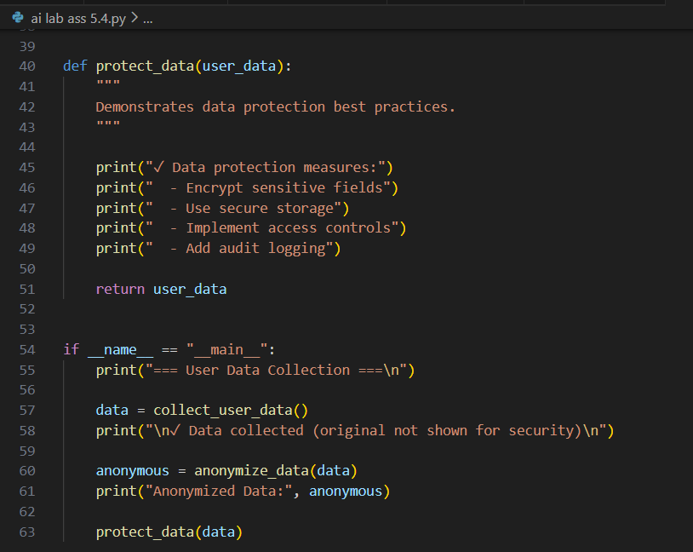
OUTPUT
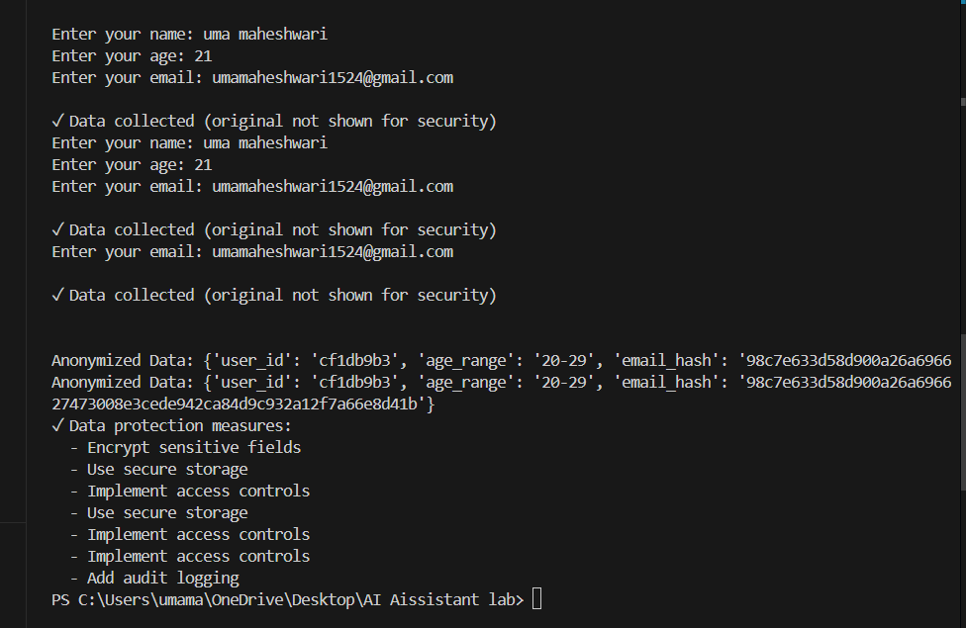
Task 2:
• Ask Copilot to generate a Python function for sentiment analysis.
Then prompt Copilot to identify and handle potential biases in the
data.
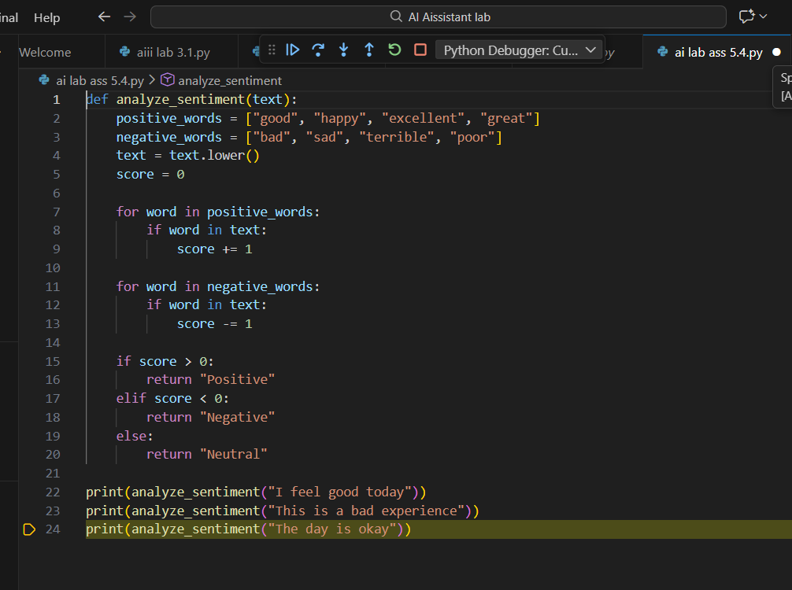
OUTPUT:
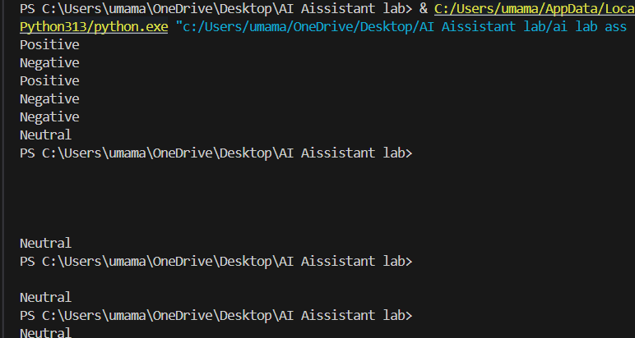
Task 3:
• Use Copilot to write a Python program that recommends
products based on user history. Ask it to follow ethical guidelines
like transparency and fairness.
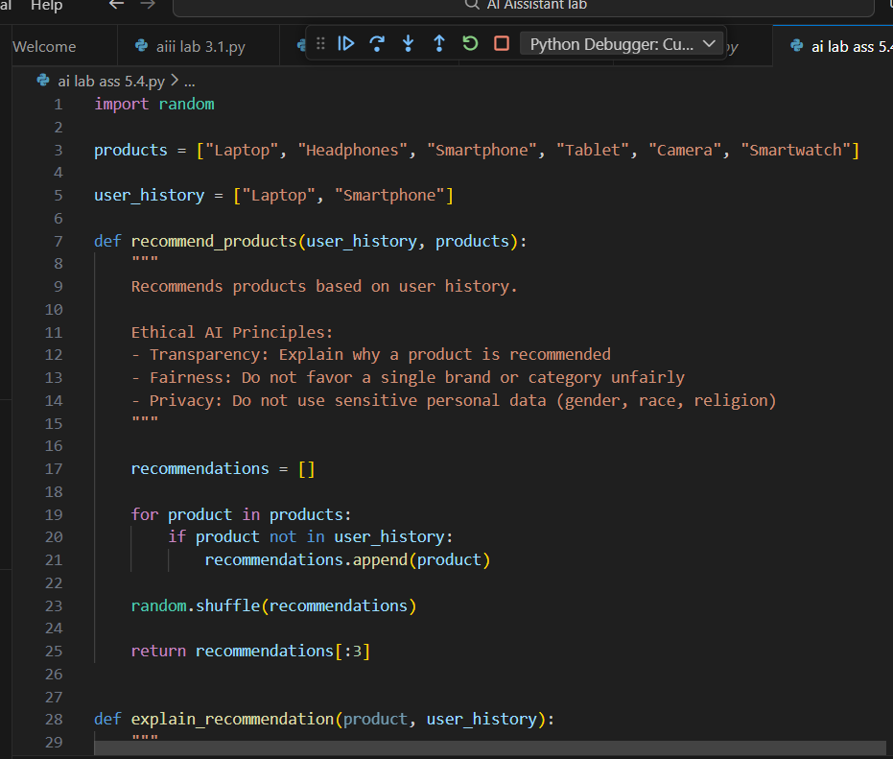
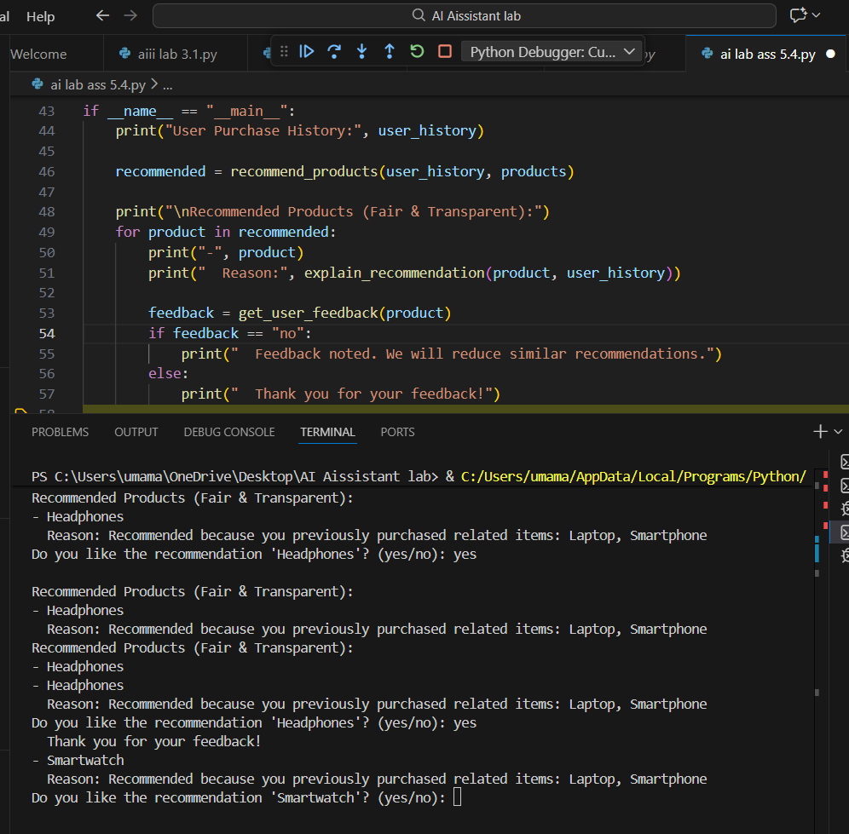
Task 4:
• Prompt Copilot to generate logging functionality in a Python web
application. Then, ask it to ensure the logs do not record sensitive
information.
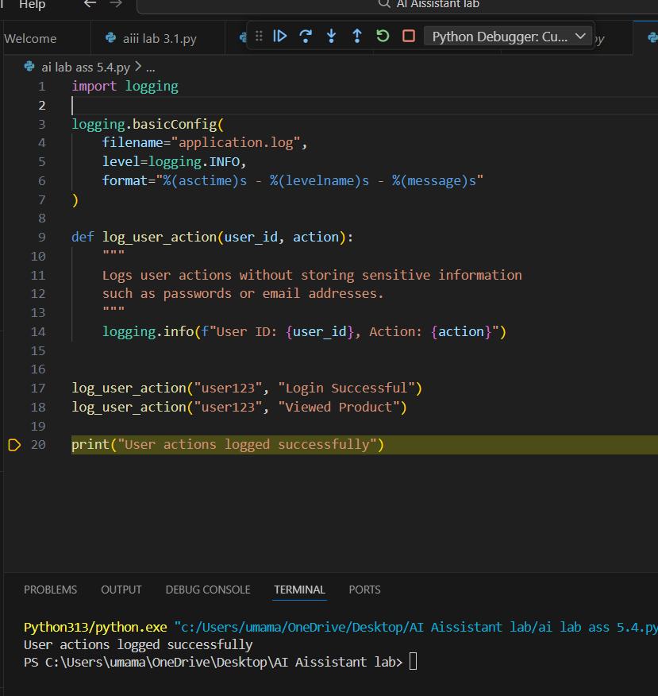
Task 5:
• Ask Copilot to generate a machine learning model. Then, prompt
it to add documentation on how to use the model responsibly
(e.g., explainability, accuracy limits).
